Carbon Graphite Stoker Bush
Copper Impregnated Carbon Stoker Bush designed for reliable performance in Travelling Grate Boilers and Waste Heat Recovery Boilers, Pusher Grate Guide Roller Boiler. Manufactured from high-quality carbon graphite material, it offers excellent wear resistance, smooth operation, and dependable performance under high-load and high-temperature conditions.
Key Features:
- Copper impregnated carbon graphite
- Suitable for high-temperature & heavy-load applications
- Excellent wear resistance and long service life
- Suitable for Travelling Grate Boiler applications
- Available for OEM and replacement requirements
- Prompt service and ex-stock availability
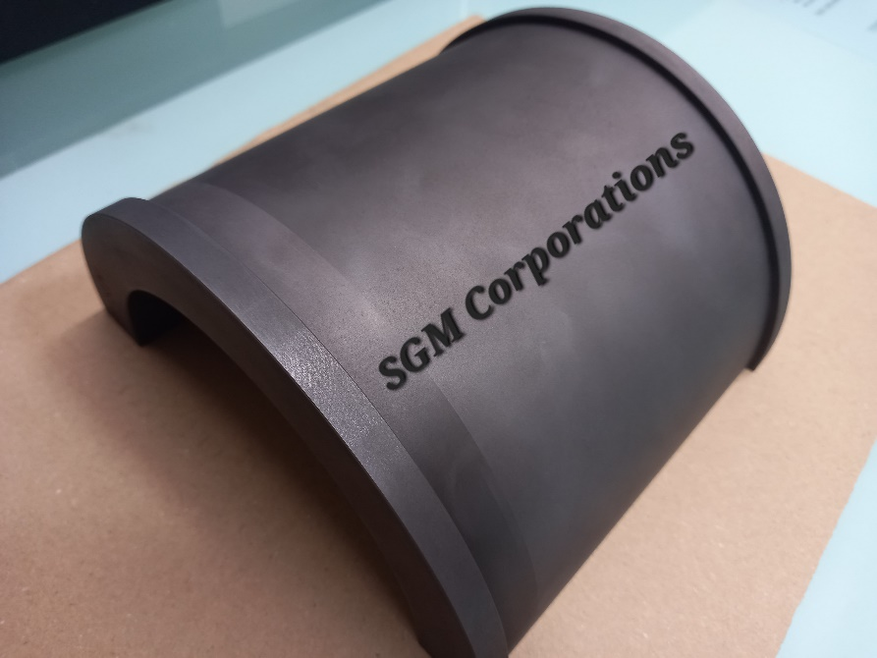 | 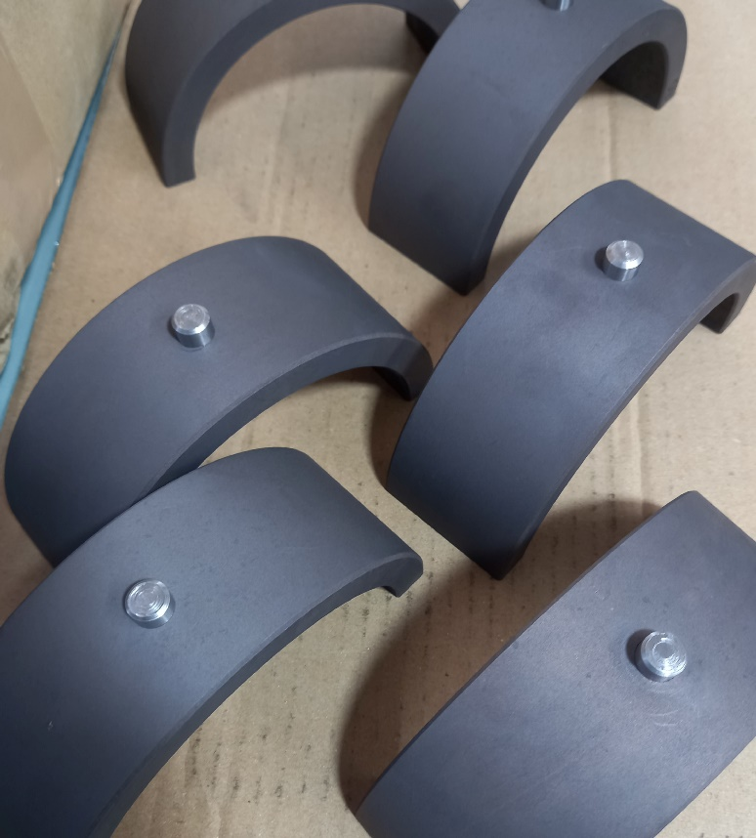

SEO- key work –
Main Keywords:
- Stoker Bush
- Carbon Stoker Bush
- Carbon Graphite Stoker Bush
- Copper Impregnated Stoker Bush
- Copper Impregnated Carbon Bush
- Travelling Grate Boiler Stoker Bush
- Boiler Stoker Bush
- Carbon Bush Bearing
- Copper Impregnated Carbon Graphite Stoker Bush
- Morganite Bush
- Travelling Grate Boiler Bush.
- Boiler Bush Bearing

